REACTIVE DATA SYSTEM [EDA]

Project Design Document

Version1.0



Professor In-Charge

Prof. Ramanathan Chandrashekar

Team Members

Bisen Vikrantsingh Mohansingh(MT2012036)
Kodamasimham Pridhvi(MT2012066)
Vaibhav Singh Rajput(MT2012155)
EDA 2
Project Design Document

Document Revision History

Version | Author | Date | Change | Reviewer | Approved
1.0 | Vaibhav Singh,  Pridhvi Kodamasimham | 22-03-2013 | First version | Vikrantsingh B | Yes

EDA 3
Project Design Document

Contents
Document Revision History..................................................................................................................... 2

Version .................................................................................................................................................... 2

Author ..................................................................................................................................................... 2

Date......................................................................................................................................................... 2

Change .................................................................................................................................................... 2

Reviewer ................................................................................................................................................. 2

Approved................................................................................................................................................. 2

Introduction ........................................................................................................................................ 4

Scope ............................................................................................................................................... 4

Intended Audience.......................................................................................................................... 4

System Overview ................................................................................................................................ 4

Design Considerations ........................................................................................................................5

Assumptions and Dependencies ......................................................................................................... 5

General Constraints ............................................................................................................................ 5

Goals and Guidelines .......................................................................................................................... 5

Development Strategy ........................................................................................................................ 5

Architectural Strategies ...................................................................................................................... 5

Detailed System Design ...................................................................................................................... 6

Testing Strategies:............................................................................................................................. 12

Reactive Data System [EDA]
EDA 4
Project Design Document

Event-driven architecture (EDA) is a software architecture pattern promoting the production, detection, consumption of, and reaction to events.

Introduction
The purpose of this document is to describe the design of the project Reactive Data System[EdA].

Scope
This document covers the Architectural Strategies, System Architecture and the Detailed System
Design associated with the project.

Intended Audience
This document is designed for all those who are involved in the software development process directly or indirectly to provide information namely features and functionality of EDA.
.

System Overview
The aim of this project is to develop Reactive data System based on Event Driven Architecture which promotes production, detection, consumption and reaction to the events. EDA will act as a framework, on which event based applications will run.

The system developed must be scalable and handle a large number of users. The high level view of the system is as follows:

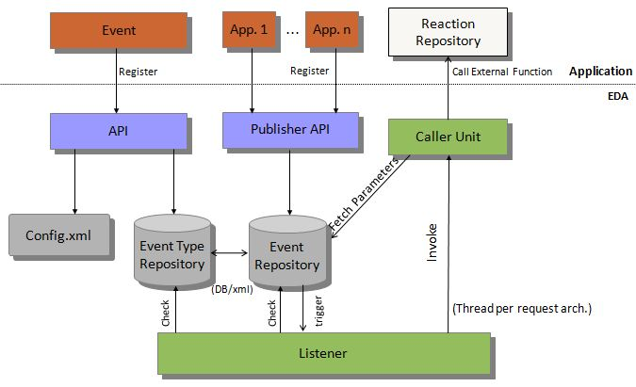

Figure 1: High Level View of System Architecture

EDA 5
Project Design Document

Design Considerations
The following points have to be taken into consideration while designing the system:

- Simple user graphical user interface (GUI)
- Any Event based application should be able to use it.
- It should be platform independent.
- Performance tuning of the system.

Assumptions and Dependencies
Following are the assumption made and dependencies which are required to meet.

- Database and web server should work properly and compatible with different system.
- Site’s resolution should be suitable considering varying browser types.
- The administrator should be well experienced of handling computer system.

General Constraints
Following are the general constraints:

- Do’s
  - The files in which the information regarding securities and portfolios should be secured against malicious deformations.
  - Data should not become corrupted in case of system crash or power failure.
  - Support Re-Engineering and Component Based Development to save time and money.
- Don’ts
  - Use of platform dependent tools should be prohibited.
  - Development from scratch.

Goals and Guidelines
The project goal is to get a fully functional Event Driven Architecture which can be used as framework for developing event based applications.

The guideline for development is to get a working prototype built as soon as feasible and improve it incrementally. The change/ improvement/enhancements should be well tested and documented.

Development Strategy
The incremental model is the development strategy that will be implemented during the development of the project.

This allows us to have an initial working model of the software and can be easily deployed and further enhancements can be added as when they are completed.

EDA 6
Project Design Document

Architectural Strategies
Event Driven Framework which will consist of mainly three components Event, Dispatcher and Action. EDA is generic framework which can be used by almost any event driven application. For demonstrating our RDS we've selected Universal admission process involving multiple Universities and students.

Detailed System Design
The class diagram that describes the design of the objects that would be utilized as part of the project is as below

Overall Class Diagram

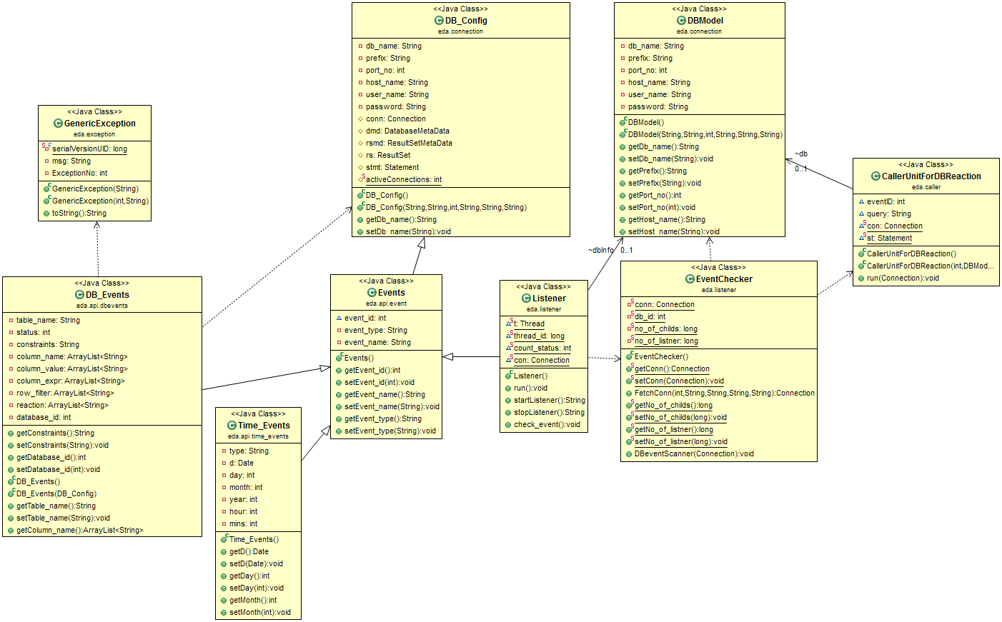

EDA 7
Project Design Document

EDA Events Class Diagram

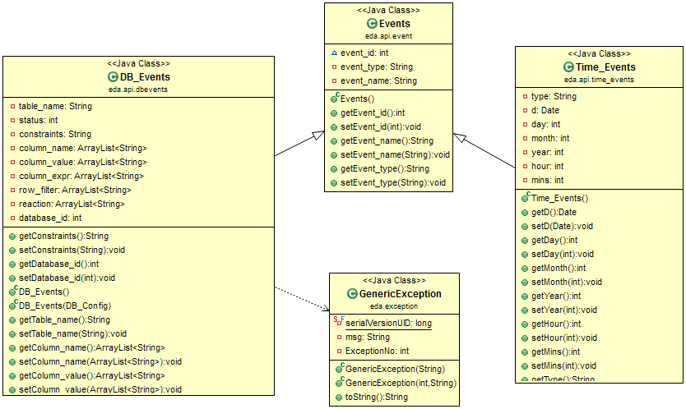

EDA Reaction Class Diagram

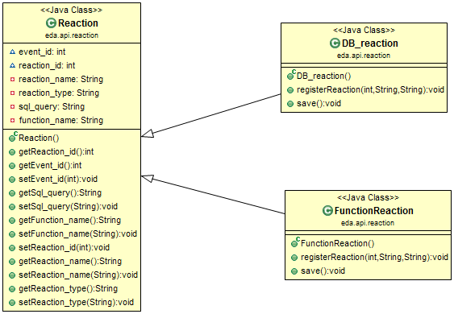
EDA 8
Project Design Document

Listener and Caller Class Diagram

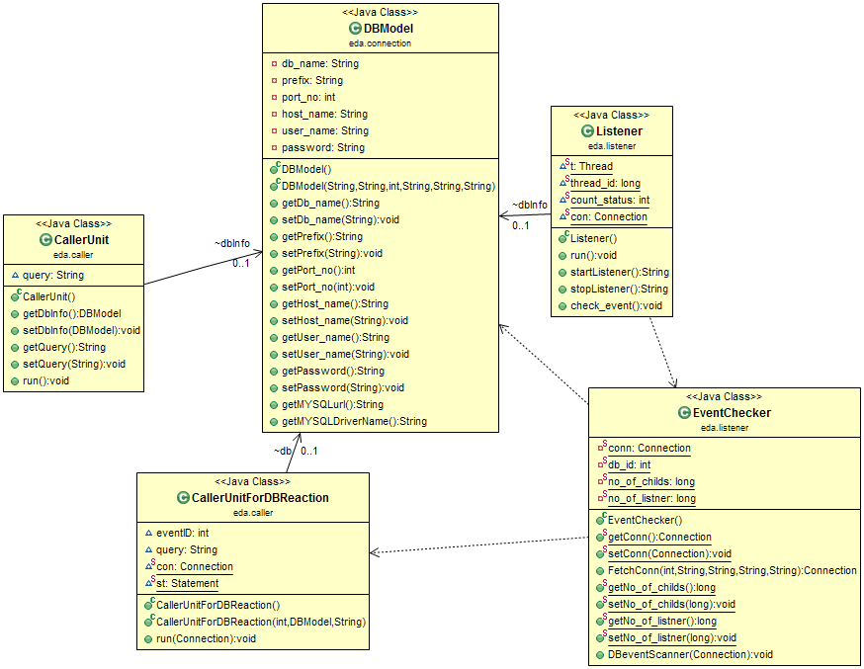

EDA 9
Project Design Document

Database Schema Design
EDA Schema

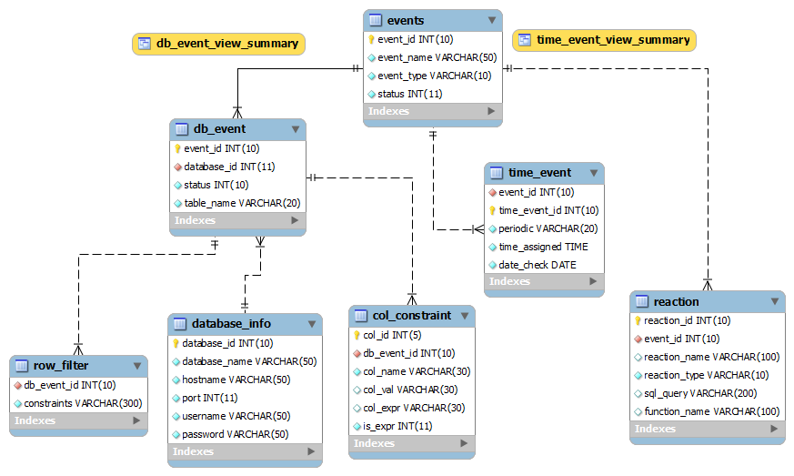

Universal Schema
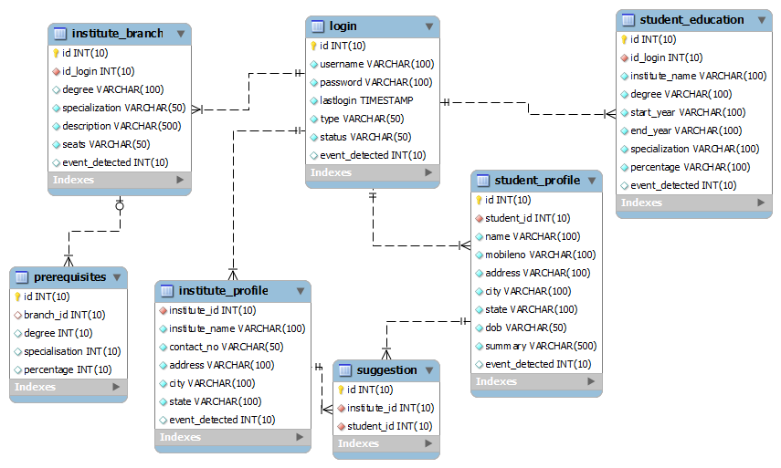
EDA 10
Project Design Document

Use Case Diagrams

EDA Admin

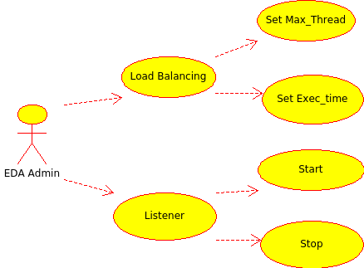

EDA 11
Project Design Document

Software Developer

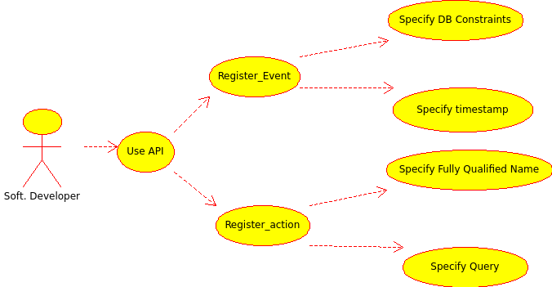
EDA 12
Project Design Document

End User

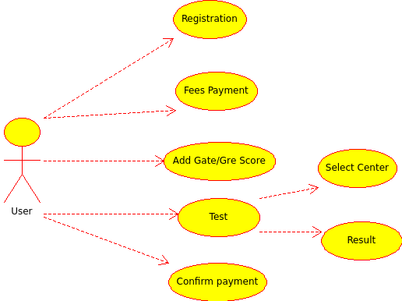

Testing Strategies:
The testing strategy for the project is as described in the Test Strategy Document.

